THE HISTORY OF EVOLUTIONARY THEORY

Darwinian Evolution
Darwin was not the first person to explain the process of evolution. Many had done so before him. Darwin’s unique contribution was that he proposed a systematic mechanism for evolution – a set of rules by which evolution occured.
His famous book was called On the Origin of Species by Means of Natural Selection. Darwin provided detailed evidence to support his ideas – much of which came from his collections from the Galapagos Islands. The book is therefore quite complex. This is surprising because the things Darwin was saying were very simple. His main ideas were:
- Living things tend to produce too many offspring.
They produce more offspring than could possibly survive. Only a small percentage of the offspring survive because resources such as food, shelters, mates etc. are limited.
- These offspring will not be identical.
The offspring will vary, even if only slightly. Nowadays, we know this is due to random mutations or combinations of genes due to sexual reproduction. You are different to your parents and siblings.
- Some of the variations (traits) in the offspring will allow them to be better adapted to their environment.
Some offspring are better able to find food, shelters, and mates. These offspring are the “fittest” and are more likely to survive in greater numbers and produce the next generation of offspring.
- Variation (traits) in organisms is inherited.
The offspring of the ‘fittest’ and most successful organisms will inherit the new successful trait
- Eventually, a population will be made up mainly of individuals with the new trait
The species has adapted to be more successful in their environment. Evolution has occurred.
Natural Selection is the term used by scientists to describe Darwin’s theory.
Describe how Scientists would use Darwin’s’ theory of natural Selection (outlined above) to explain the following observations.
  - In some species of birds, the parent birds do not give food to each chick (baby bird). The chicks have to fight for the food brought back to the nest by the parents.
Birds have more chicks than will survive. The chicks are all different to each other. The larger and stronger chicks will fight to get more food and will survive while the weaker smaller chicks die. The larger and stronger chicks are “better adapted” to their environment. When they eventually mate they will pass on these traits to the next generation of birds. The next generation will therefore typically be “better adapted” than the previous generation
  - In the 1970s, on the Galápagos Islands, a drought occurred. As a result, fewer seeds were available for finches to eat. Birds with smaller beaks could crack open and eat only the smaller seeds. Birds with bigger beaks could crack and eat seeds of all sizes. As a result, many of the small-beaked birds died in the drought. Birds with bigger beaks survived and reproduced. Within 2 years, the average beak size in the finch population increased.
Birds with bigger beaks were “better adapted” to the changing conditions (fewer seeds), and could acess more food than birds with small beaks. Birds with bigger beaks were more likely to survive and the birds with smaller beaks more likely to die. When birds with bigger beaks mate, they pass on this characteristic to their offspring. This means the next generation has larger beaks than the previous generation

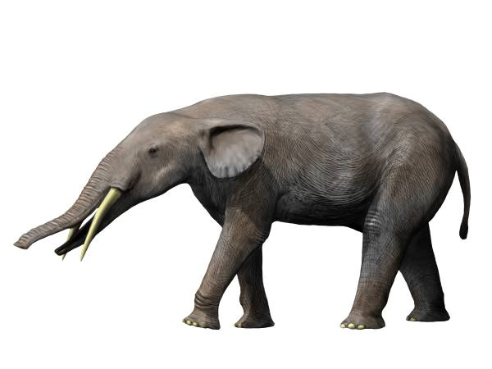
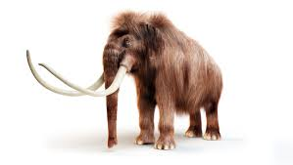
  - African elephants, Asian elephants, and Mammoths (now extinct), all had a common ancestor – Gomphotherium. A brief description of each is given below.
Gomphotherium – were approximately 2.5 metres tall, and had four relatively short tusks. Their natural habitat ranged from swamps to forests. Their diet was plant based. Ancestor of the modern elephant – lived from 5 million year age to 2 millions years ago
African elephant – are about 3.5 metres tall, have two long tusks, and large ears. Their natural habitat is open grasslands in Africa.
Asian elephant – are about 2.5 metres tall, males have two small tusks, and small ears. Their natural habitat is dense forests and jungle.
Woolly Mammoth – were approximately 4 metres tall, had two very long tusks, and very small ears. They were covered with wool. Their natural habitat was tundra (cold but well vegetated grasslands). They had a bulge of stored fat on their back. They are now extinct (~10000 yrs ago).
Use Darwin’s theory of evolution to explain how each of the three types of modern elephant may have evolved from Gomphotherium.

The ancient elephant evolved into the three other types of elephants as the elephants migrated and moved into areas which had different habitats.
- The elephant has more young than will survive
- These young will all be slightly different to each other
- IN their new habitat, those young elephants with useful or better adapted characteristics will survive and those with less adapted characteristics to die.
For example
- In Africa where there are open grasslands, the young elephants which were taller (stand above the grass), and able to cool themselves easily (large ears) are better adapted
- In Asia where there is dense jungle, the young elephants which were smaller (can move more easily through the jungle) were better adapted
- In the Tundra, the young elephants which were well insulated against the cold conditions (wool and stored fat) were better adapted
- Over time, the elephants with the better adapted traits were more successful and survived to reproduce and pass on these traits to the next generation
- Eventually the populations of elephants in the three regions did not look anything like the ancient elephant.

Note the use of Darwin’s theory as much as possible, but with examples for the information given in the question. The main part of the answer (almost always) is the third point of Darwin’s theory.

